Domain-Specific RAG Chatbot
Project Report
Unlox Academy — Major Project 3

Student Name: Navyashree K N
Live Application: https://domain-rag-chatbotgi-jajxu6e28othk9ehy6ys7j.streamlit.app
GitHub Repository: https://github.com/Navyachalla21/domain-rag-chatbot

1. Introduction
Large documents are difficult to search manually — finding a single answer can mean reading through many pages. This project addresses that problem by building a Retrieval-Augmented Generation (RAG) chatbot that allows users to upload PDF documents and ask questions in natural language, receiving answers grounded strictly in the uploaded content, with clear source and page citations.

2. Objective
To build a reliable, domain-specific question-answering system that:
- Extracts and processes text from user-uploaded PDF documents.
- Retrieves the most relevant passages for a given question using semantic search.
- Generates answers grounded only in retrieved content, refusing to answer when information is unavailable.
- Displays the exact source document and page number behind every answer.
- Provides a simple, usable web interface and a live deployed link.

3. Approach and Methodology
The system follows a standard RAG (Retrieval-Augmented Generation) pipeline, built and tested module by module:

Document Upload & Extraction
Uploaded PDFs are validated for file type and size (50MB limit per file) before processing. Each page's extracted text is tagged with its source filename and page number as metadata using pypdf, and empty or unreadable pages are safely skipped. A dedicated “Clear Docs” control lets the user fully reset uploaded documents and the vector index to start fresh with a new document set.

Chunking
Extracted text is split into smaller, overlapping chunks (approximately 800 characters with 120 characters of overlap) using LangChain's RecursiveCharacterTextSplitter. Overlap ensures ideas split across chunk boundaries remain intact in at least one chunk, and smaller chunks allow embeddings to represent focused, specific ideas rather than a vague average of an entire page.

Embeddings and Vector Storage
Each chunk is converted into a numerical vector (embedding) using the all-MiniLM-L6-v2 Sentence Transformer model, chosen for being lightweight, free, and fast enough to run locally on CPU. The model is cached at the session level to avoid reloading on every rerun. These embeddings, along with their source/page metadata, are stored in a FAISS vector index for efficient similarity search.

Retrieval
When a user asks a question, the question is embedded using the same model, and FAISS retrieves the top 4 matching chunks by vector similarity, along with their source document and page number. Retrieved chunks are grouped by source file with unique, sorted page numbers before being shown to the user.

Answer Generation
The retrieved chunks and the user's question are passed to Google's Gemini model with a strict system prompt instructing it to answer only from the supplied context, mention the source document and page number, and explicitly state “I could not find this information in the uploaded documents” when the answer is not present, rather than inventing an answer. API errors (such as transient model unavailability) are caught and surfaced to the user as a clear error message rather than crashing the application.

User Interface
A Streamlit-based chat interface allows users to upload PDFs, process them, and ask questions through a familiar chat-style layout. Retrieved sources are shown below each answer, only when an actual answer was generated (not on refusal), avoiding misleading source displays.

4. Architecture Diagram
[Insert architecture diagram here]

5. Tools and Technologies
Component | Tool
Programming Language | Python
PDF Text Extraction | pypdf
Text Splitting | LangChain Text Splitters
Embeddings | Sentence Transformers (all-MiniLM-L6-v2)
Vector Database | FAISS
Language Model | Google Gemini (gemini-3.6-flash)
User Interface | Streamlit
Environment Variables | python-dotenv
Deployment | Streamlit Community Cloud
Version Control | Git and GitHub

6. Application Screenshots
The screenshots below show the deployed chatbot answering in-scope questions with correct source and page citations.
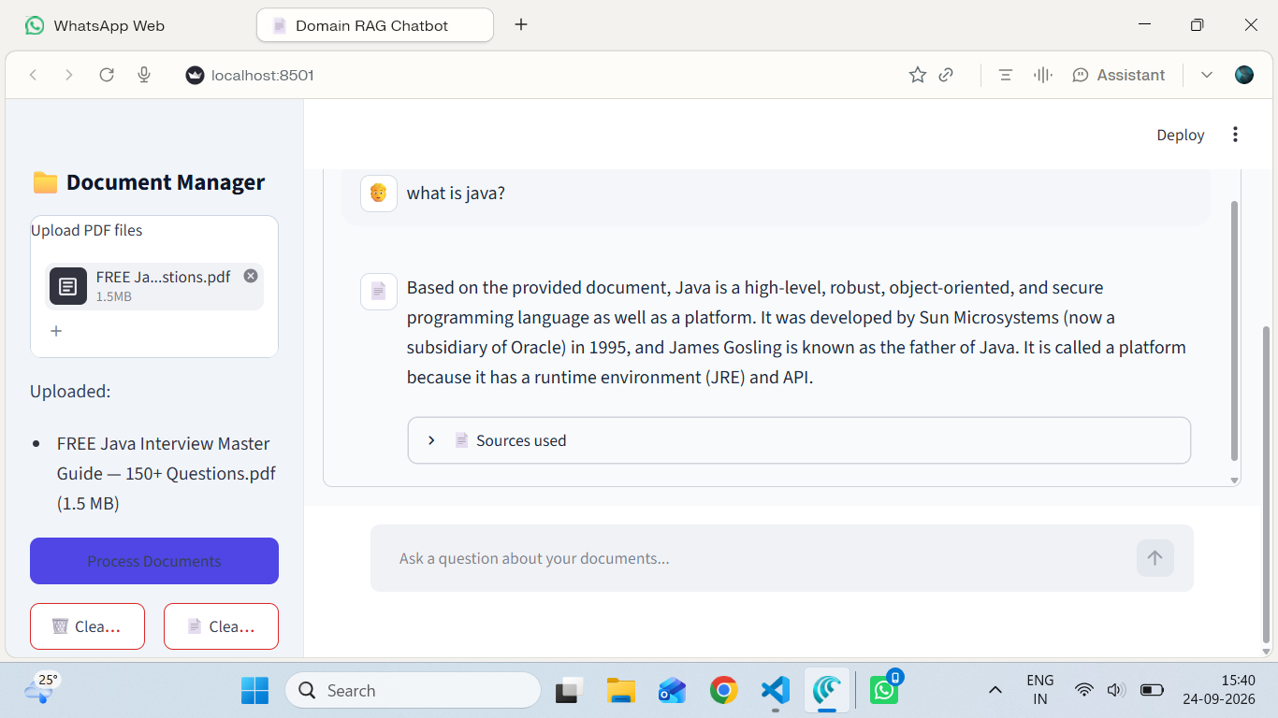
Figure 1: Chatbot answering a general question (“what is java?”) grounded in the uploaded Java interview guide.
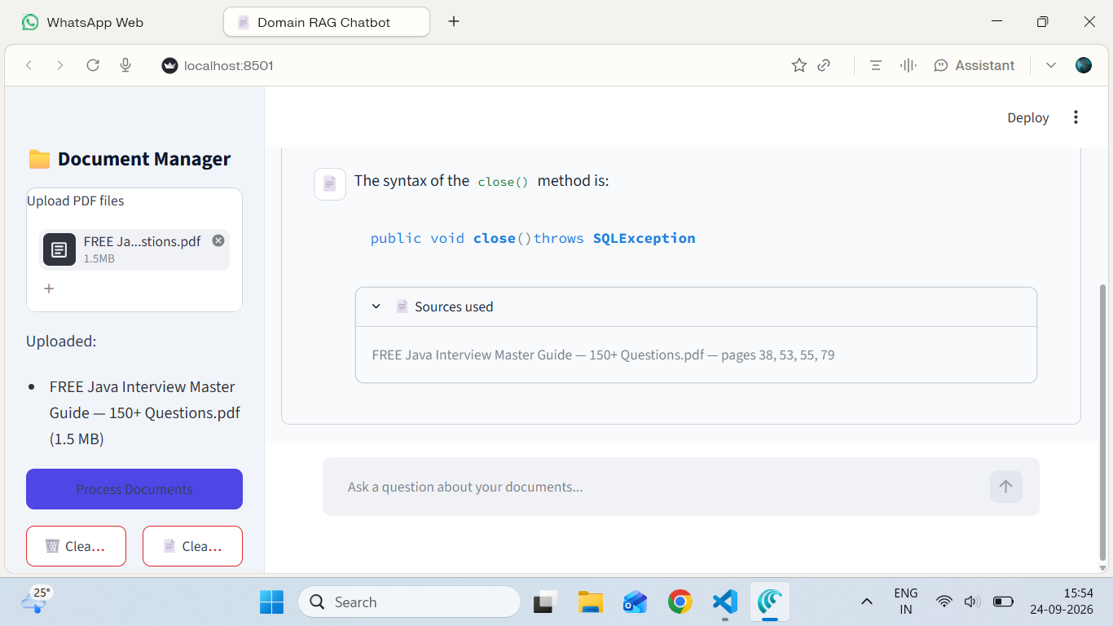
Figure 2: Answer with expanded “Sources used” panel, showing the source document and cited page numbers.
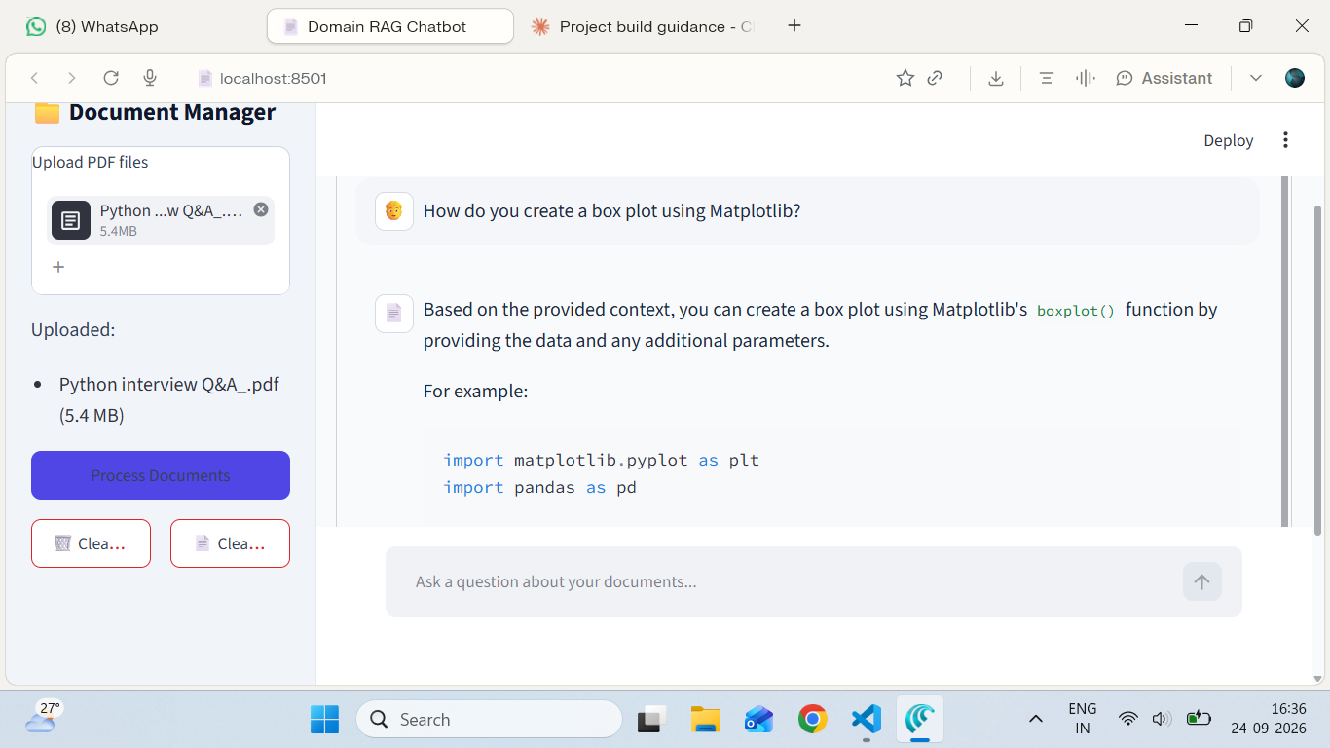
Figure 3: Chatbot answering a Python/Matplotlib question from a different uploaded document, with a code example in the response.

7. Testing and Evaluation
The chatbot was tested with 15 questions spanning three categories: in-scope questions directly answerable from the uploaded PDF, edge-case questions that may not be explicitly covered, and out-of-scope questions unrelated to the uploaded content, used to confirm the refusal guardrail behaves correctly. Each test question was evaluated on retrieval accuracy, answer groundedness, and correct source/page citation. Testing also surfaced a transient upstream API error (HTTP 503, model temporarily unavailable), confirming the application's error handling displays a clear message to the user instead of crashing.
[Insert testing screenshots / summary table here]
Full test results are available in the project repository at tests/test_questions.csv.

8. Results and Observations
The chatbot successfully answered in-scope questions with correct source and page citations. For out-of-scope and greeting-style questions (e.g. “Hi”, “Hello”), the system correctly refused to answer rather than fabricating a response, confirming the groundedness guardrail works as intended. A transient LLM provider outage during testing was handled gracefully, surfacing a clear error message rather than an application crash — validating the basic error handling requirement under real conditions rather than a simulated one.

9. Limitations
- Answers are entirely dependent on the content of the uploaded PDF; the system cannot draw on general knowledge.
- Scanned or image-only PDF pages without extractable text are skipped rather than processed via OCR.
- Retrieval quality can vary for loosely worded or ambiguous questions.
- The deployed application's vector store resets on redeploy and must be rebuilt by re-processing documents.
- Answer generation depends on third-party LLM API availability; brief outages on the provider's side can temporarily prevent answer generation.

10. Future Improvements
- Add OCR support for scanned/image-based PDF pages.
- Persist the vector store across deployments using cloud storage.
- Add conversation memory to support natural follow-up questions.
- Support multiple document collections with filtering by collection.
- Expand automated evaluation with a larger, structured question-answer test set.
- Add automatic retry logic for transient LLM provider errors.

11. Conclusion
This project demonstrates a complete, working Retrieval-Augmented Generation pipeline — from PDF ingestion through chunking, embedding, retrieval, and grounded answer generation — deployed as a live, publicly accessible web application. The system reliably answers questions from uploaded content, correctly declines to answer when information is unavailable, handles upstream errors gracefully, and provides transparent source attribution for every answer, meeting the core objectives of a trustworthy document question-answering assistant.

